Mini Project Report

of

Database Systems Lab (CSS 2212)

ONLINE SHOPPING CART
MANAGEMENT SYSTEM

SUBMITTED

BY

AKSHITA KAMBHAMPATI, REG.NO: 240953049, CCE-A, 07

NEHA DAS, REG.NO: 240953396, CCE-A, 30

School of Computer Engineering
Manipal Institute of Technology, Manipal.
April 2026

SCHOOL OF COMPUTER ENGINEERING

Manipal

06/04/2026

CERTIFICATE

This is to certify that the project titled Online Shopping Cart Management System is a record of the Bonafide work done by Akshita Kambhampati (240953049) and Neha Das (240953396) submitted in partial fulfilment of the requirements for the award of the Degree of Bachelor of Technology (B.Tech.) in COMPUTER AND COMMUNICATION ENGINEERING of Manipal Institute of Technology, Manipal, Karnataka, (A Constituent Institute of Manipal Academy of Higher Education), during the academic year 2025-2026.

Name and Signature of Examiners:

Dr. Anup Bhat B, Assistant Professor, SCE.

Dr. ….., …., SCE.

ABSTRACT

This online shopping portal is a complete online shopping program that allows users to efficiently perform many items of online shopping activities. Users will be able to see all the products they want in their shopping carts before eventually purchasing.

An Administrator will manage product information and product stock for each item in the Shopping Cart System. This gives the system the ability to sell products to customers when there is available stock and will keep accurate records of all purchases by users.

The Shopping Cart System contains a database that allows customers, products, shopping cart items, and order information to be maintained in a manner that allows easy retrieval of the records, at the same time maintaining a consistent record across all users and transactions.

This project illustrates how a DBMS can be used for managing a real-world application with multiple users that perform more than one transaction.

ACM Taxonomy:

- Database Management
- Data Integrity
- Transaction Processing

Sustainable Development Goal (SDG):

- Industry, Innovation and Infrastructure

TABLE OF CONTENTS

CHAPTER 1: INTRODUCTION ……………………………………………. 9
  - Introduction ………………………………………………………….............. 9
  - Need for System ………………………………………………………...….... 9
  - Scope …………………………………………………………………............ 10
CHAPTER 2: PROBLEM STATEMENT & OBJECTIVES ……………… 11
2.1 Problem Statement ………………………………………………………….... 11
2.2 Objectives ……………………………………………………………………..11
CHAPTER 3: DATABASE DESIGN ………………………...……………... 12
3.1 ER Diagram ……....…………………………………………………………..12
3.2 Relational Schema.…………………………………………………………....13
3.3 Normalization ………………………………………………………………...13
CHAPTER 4: DDL COMMANDS & SQL ……………………...………….14
CHAPTER 5: RESULTS AND SNAPSHOTS…..…………...…………….. 23
CHAPTER 6: DATABASE DESIGN ………………………...……………... 32
  - Conclusion:………………………...……....………………………………………………..……….….
  - Limitations ………………………………..……………………………………………………………….
  - Future Work …………………………………………………………………………………..………….
CHAPTER 7: REFERENCES ………………………………...………………33

LIST OF TABLES

ENTITIES:

- USER
- PRODUCT
- SHOPPING_CART
- CART_ITEM
- ORDER
- ORDER_ITEM
- CATEGORY

TABLES:

- USER (user_id PK, name, email, phone, address, password)
- PRODUCT (product_id PK, name, description, price, stock_qty, category)
- CART (cart_id PK, customer_id FK, created_at, status)
- CART_ITEM (cart_item_id PK, cart_id FK, product_id FK, quantity)
- ORDER (order_id PK, customer_id FK, order_date, total_amount, status, payment_method)
- ORDER_ITEM (order_item_id PK, order_id FK, product_id FK, quantity, unit_price)
- CATEGORY(category_id, category_name)

LIST OF FIGURES

Figure 1.1: Three Tier Architecture
Figure 3.1: ER Diagram
Figure 4.1: Tables
Figure 5.1: Login Page
Figure 5.2: Product Page
Figure 5.3: Search Product
Figure 5.4: Add to Cart
Figure 5.5: Shopping Cart
Figure 5.6: Remove Item from Cart
Figure 5.7: Checkout Page
Figure 5.8: Order History Page
Figure 5.9: Admin Page
Figure 5.10: Add Product (Admin)
Figure 5.11: Delete Product (Admin)
Figure 5.12: Update Product (Admin)

Abbreviations

DBMS – Database Management System
SQL – Structured Query Language
DDL – Data Definition Language
DML – Data Manipulation Language
ER – Entity Relationship
PK – Primary Key
FK – Foreign Key
UI – User Interface
JDBC – Java Database Connectivity
PL/SQL – Procedural Language / SQL
GUI – Graphical User Interface

CHAPTER 1
INTRODUCTION

  - Introduction:

Shop Online is a necessity now and this Online Shopping Cart Management System project's goal is to develop an efficient way for customers to browse, manage their shopping carts, and place orders on the web.

There are two types of users in this system, customers and administrators. Customers will be able to browse through available products, add items to their shopping carts and make purchases, while Administrators will maintain product information and stock levels.

This system will use a Database Management System (DBMS) that stores and manages all data related to users, products, shopping carts, and order history. In this way we can ensure that all data is secure and follows proper protocols; therefore, providing a reliable and efficient way of storing and accessing all information.

  - Need for System:
As more and more people shop online, there is a need for efficient systems to handle large amounts of user and product data. Errors like wrong stock updates, duplicate records, and failed transactions can happen when systems are not well-organised or are done by hand.
A good database system makes sure that:
Quick access to data
Managing stock correctly
Transactions that are safe
A better experience for users

  - Scope:

The system focuses on managing:
- User accounts
- Product inventory
- Shopping cart operations
- Order processing

Figure 1.1: Three Tier Architecture

Presentation
Java Swing GUI

Application
JDBC+PL/SQL
(procedures and triggers)

Data
Database
(tables and inputs)

CHAPTER 2
PROBLEM STATEMENT & OBJECTIVES

  - Problem Statement:

When you shop the old-fashioned way, keeping track of product availability, user data, and transactions by hand can cause mistakes and waste time. We need a system that can automate shopping, keep data safe, and make the experience for users as smooth as possible.
The Online Shopping Cart Management System solves these problems by giving you a structured database to use to keep track of products, users, and transactions.

  - Objectives:

- Store user information
- Store product details
- Allow users to browse products
- Enable adding items to cart
- Allow removal of items from cart
- Check product availability before purchase
- Generate order records
- Update stock after purchase
- Store transaction details
- Allow admin to manage products
- Maintain data integrity
- Allow users to view previous orders

CHAPTER 3
DATABASE DESIGN

  - ER Diagram:

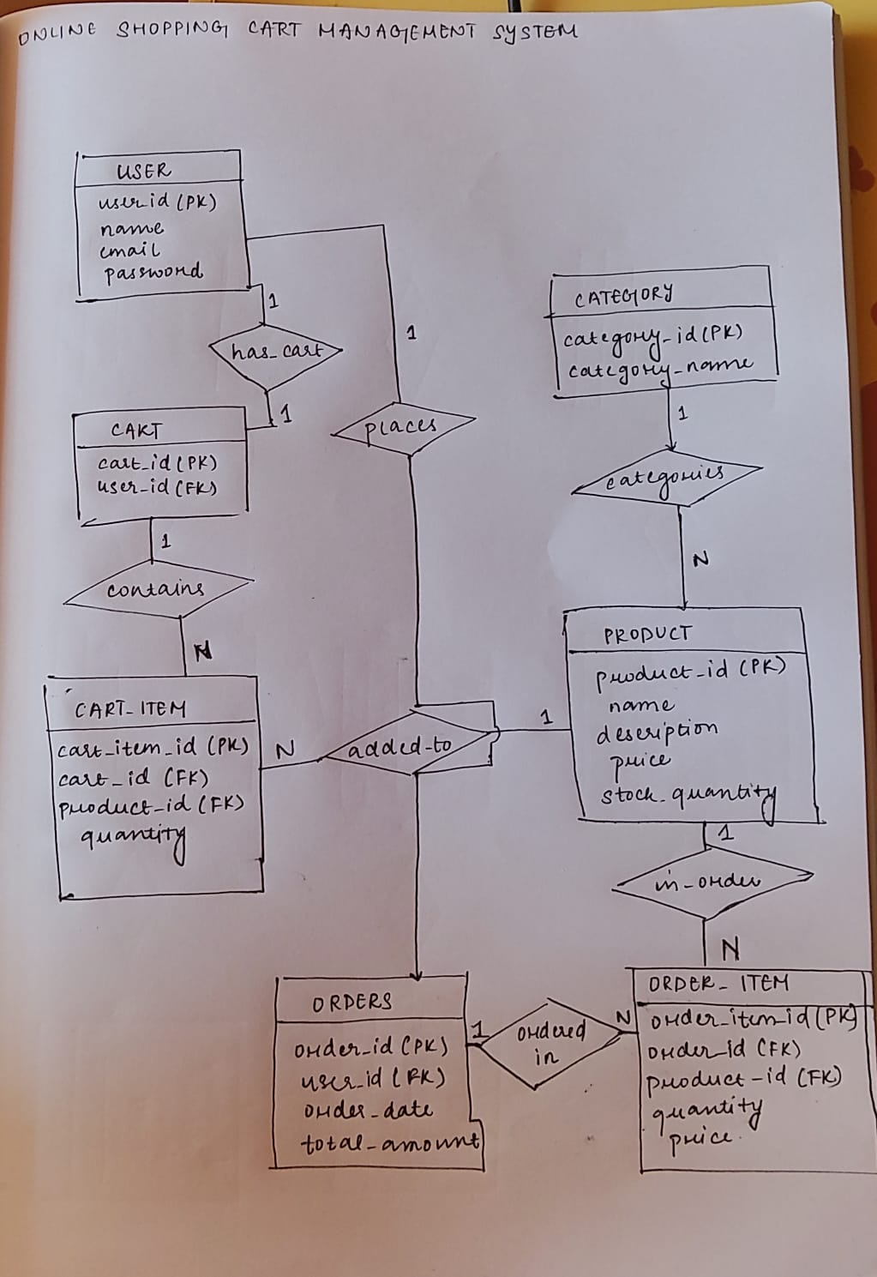

  - Relational Schema:
- USER(user_id PK, name, email, phone, address, password)
- PRODUCT(product_id PK, name, description, price, stock_qty, category)
- SHOPPING_CART(cart_id PK, customer_id FK, created_at, status)
- CART_ITEM(cart_item_id PK, cart_id FK, product_id FK, quantity)
- ORDER(order_id PK, customer_id FK, order_date, total_amount, status, payment_method)
- ORDER_ITEM(order_item_id PK, order_id FK, product_id FK, quantity, unit_price)
- CATEGORY(category_id, category_name)
  - Normalization:

- The database is normalized to avoid duplication and ensure data integrity.
- It follows three normal forms: 1NF, 2NF, and 3NF.
- Ensures that all attributes depend only on the primary key and removes transitive dependencies.
First Normal Form (1NF)
Rules:
- No repeating groups
- Only atomic (single-valued) attributes
Implemented:
- All attributes in tables are atomic
- No multi-valued attributes are present
- Example: Products are stored separately instead of inside Order_Item

Second Normal Form (2NF)
Rules:
- Table must be in 1NF
- No partial dependency on composite primary keys
Implemented:
- Use of surrogate primary keys (e.g., cart_item_id, order_item_id)
- All non-key attributes fully depend on the primary key
Example:
- Order_Item(order_item_id, order_id, product_id, quantity, price)
- No partial dependency exists
Third Normal Form (3NF)
Rules:
- Table must be in 2NF
- No transitive dependency
Implemented:
- Data is split into separate tables to avoid redundancy
- Product details do not include category name directly
Example:
- Incorrect:
  - Product(product_id, name, category_name)
- Correct:
  - Product(product_id, name, category_id)
  - Category(category_id, category_name)
CHAPTER 4
DDL COMMANDS & SQL
CREATE TABLE USER (
user_id INT PRIMARY KEY,
name VARCHAR(50),
email VARCHAR(50) UNIQUE,
password VARCHAR(50),
role VARCHAR(20)
);

CREATE TABLE CATEGORY (
category_id INT PRIMARY KEY,
category_name VARCHAR(50)
);

CREATE TABLE PRODUCT (
product_id INT PRIMARY KEY,
name VARCHAR(50),
description VARCHAR(100),
price DECIMAL(10,2),
stock_quantity INT,
category_id INT,
FOREIGN KEY (category_id) REFERENCES CATEGORY(category_id)
);

CREATE TABLE CART (
cart_id INT PRIMARY KEY,
user_id INT,
FOREIGN KEY (user_id) REFERENCES USER(user_id)
);

CREATE TABLE CART_ITEM (
cart_item_id INT PRIMARY KEY,
cart_id INT,
product_id INT,
quantity INT,
FOREIGN KEY (cart_id) REFERENCES CART(cart_id),
FOREIGN KEY (product_id) REFERENCES PRODUCT(product_id)
);

CREATE TABLE ORDERS (
order_id INT PRIMARY KEY,
user_id INT,
order_date DATE,
total_amount DECIMAL(10,2),
FOREIGN KEY (user_id) REFERENCES USER(user_id)
);

CREATE TABLE ORDER_ITEM (
order_item_id INT PRIMARY KEY,
order_id INT,
product_id INT,
quantity INT,
price DECIMAL(10,2),
FOREIGN KEY (order_id) REFERENCES ORDERS(order_id),
FOREIGN KEY (product_id) REFERENCES PRODUCT(product_id)
);

SAMPLE INPUTS :
INSERT INTO users (name, email, password, role) VALUES ('Neha','neha@gmail.com','1234','customer');
INSERT INTO users (name, email, password, role) VALUES ('Akshita','akshita@gmail.com','1234','customer');
INSERT INTO users (name, email, password, role) VALUES ('Admin1','admin1@gmail.com','admin','admin');

INSERT INTO category (category_name) VALUES ('Electronics');
INSERT INTO category (category_name) VALUES ('Clothing');

INSERT INTO product (name, description, price, stock_quantity, category_id) VALUES ('Laptop', 'Dell Inspiron',60000,10,1) ;
INSERT INTO product (name, description, price, stock_quantity, category_id) VALUES ('Mobile', 'Samsung Galaxy',20000,15,1) ;

INSERT INTO cart (user_id) VALUES (1) ;
INSERT INTO cart (user_id) VALUES (2) ;

INSERT INTO cart_item (cart_id, product_id, quantity) VALUES (1,1,1) ;
INSERT INTO cart_item (cart_id, product_id, quantity) VALUES (1,3,2) ;

INSERT INTO orders (user_id, order_date, total_amount) VALUES (1, TO_DATE('2026-03-01','YYYY-MM-DD'), 63000) ;
INSERT INTO orders (user_id, order_date, total_amount) VALUES (2, TO_DATE('2026-03-05','YYYY-MM-DD'), 21500) ;

INSERT INTO order_item (order_id, product_id, quantity, price) VALUES (1,1,1,60000) ;
INSERT INTO order_item (order_id, product_id, quantity, price) VALUES (1,3,2,1500) ;
TABLES:

Figure: 4.1
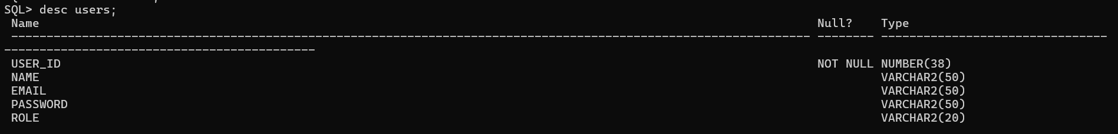
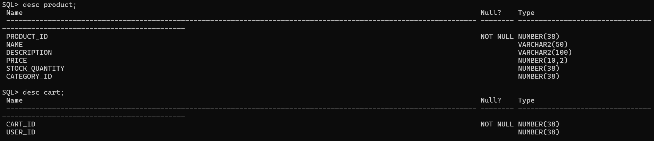
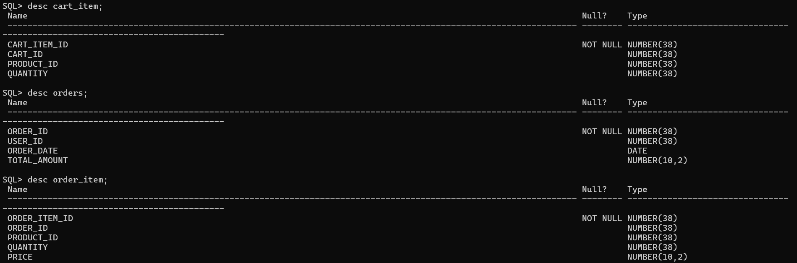

PROCEDURES/TRIGGERS IMPLEMENTED:

ADD_PRODUCT: procedure used to insert a new product into the PRODUCT table by the admin

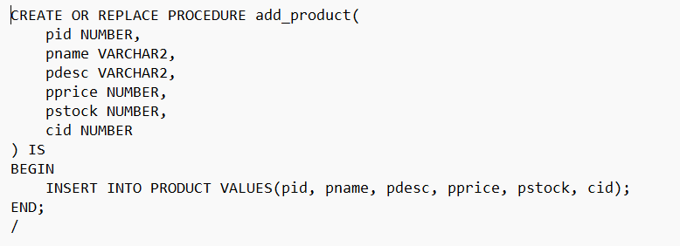

CART_ITEM_SEQ + CART_ITEM_TRIGGER: used to automatically generate unique IDs for cart items.

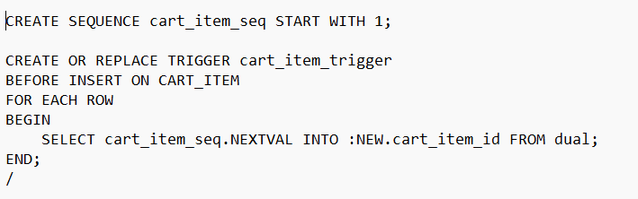

CART_SEQ + CART_TRIGGER: used to automatically generate unique cart_id for the CART table.

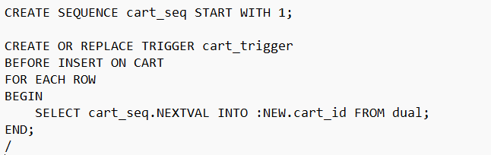

CATEGORY_SEQ+ CATEGORY_TRIGGER: used to automatically generate unique IDs for the CATEGORY table.

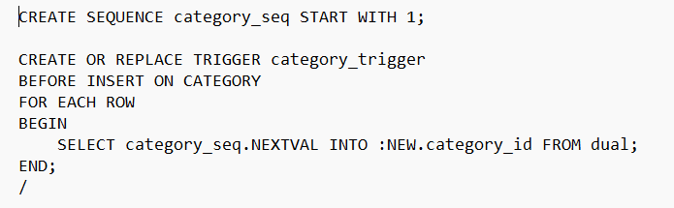

ORDER_ITEM_SEQ+ ORDER_ITEM_TRIGGER: used to automatically generate unique IDs for the ORDER_ITEM table.

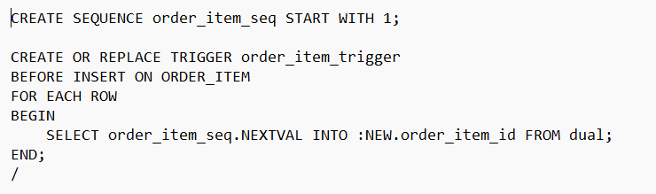

ORDERS_SEQ+ ORDERS_TRIGGER: used to automatically generate unique IDs for the ORDERS table.

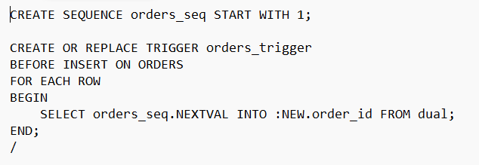

PRODUCT_SEQ + PRODUCT_TRIGGER: sequence and a trigger used to automatically generate unique IDs for the PRODUCT table.

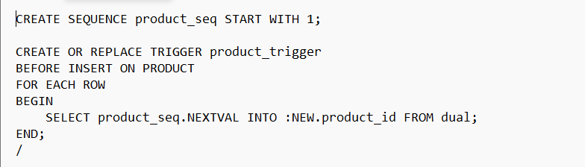

DELETE_PRODUCT: procedure used to remove a product from the PRODUCT table by the admin.

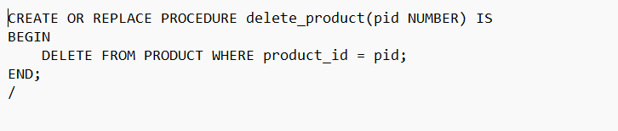

CHECK_STOCK: trigger used to validate product availability before placing an order.

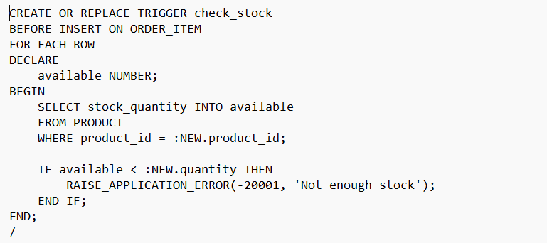

UPDATE_PRODUCT: procedure used to modify the price and stock of an existing product in the PRODUCT table.

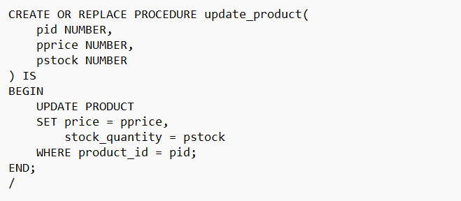
UPDATE_STOCK: trigger used to automatically reduce product stock after an order is placed.

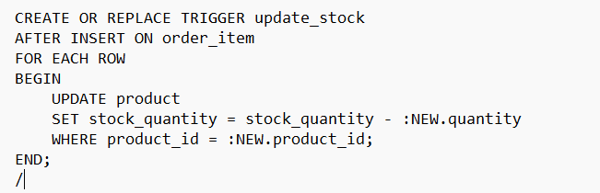

PLACE_ORDER: procedure used to convert a user’s cart into a complete order.

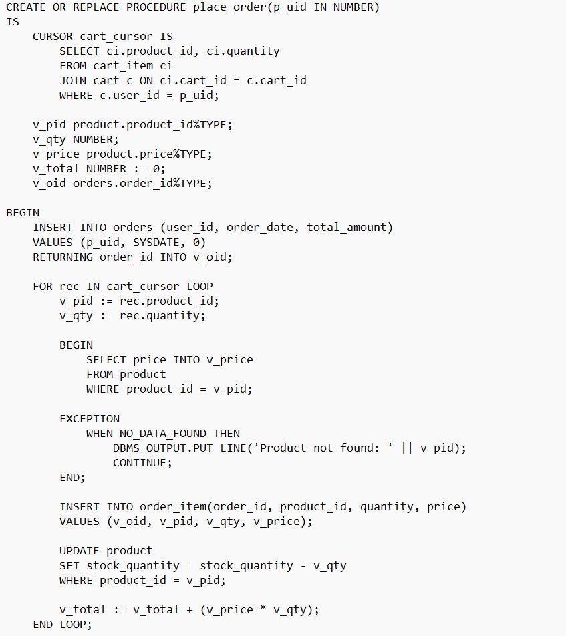
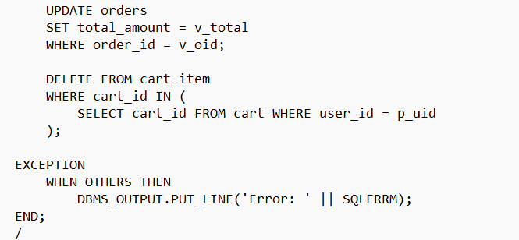

ADD_TO_CART: procedure used to add an item to the cart.

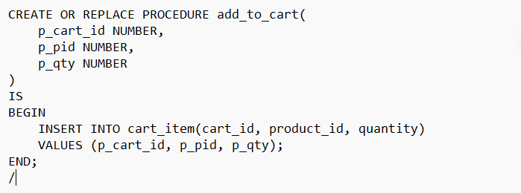

REMOVE_FROM_CART: procedure used to remove an item from the cart.
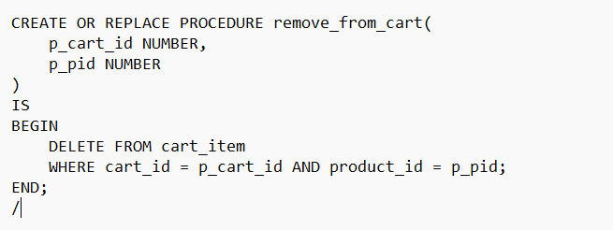

SEARCH_PRODUCT : procedure used to search a product in the PRODUCT table.

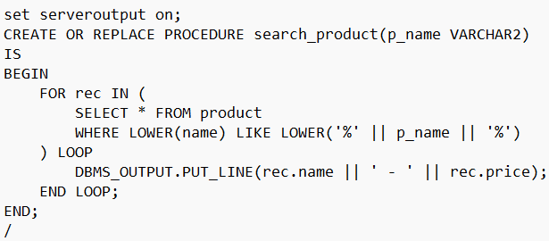

VIEW_ORDERS : procedure used to view past orders of that customer.

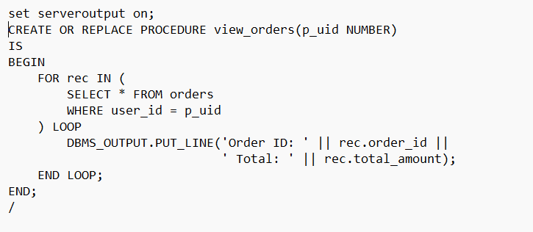

CHAPTER 5
RESULTS & SNAPSHOTS
Screenshots of table creation and query execution are included.

LOGIN PAGE:
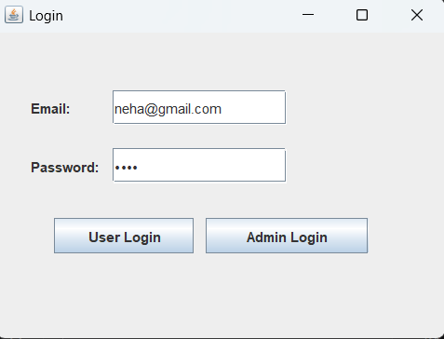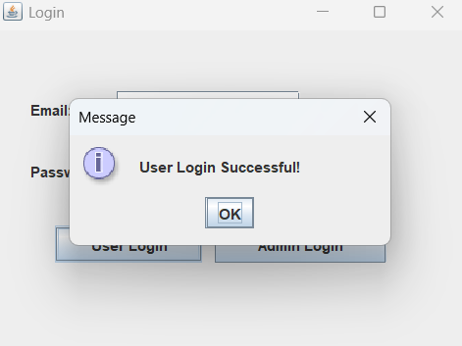
Figure 5.1

PRODUCT PAGE:

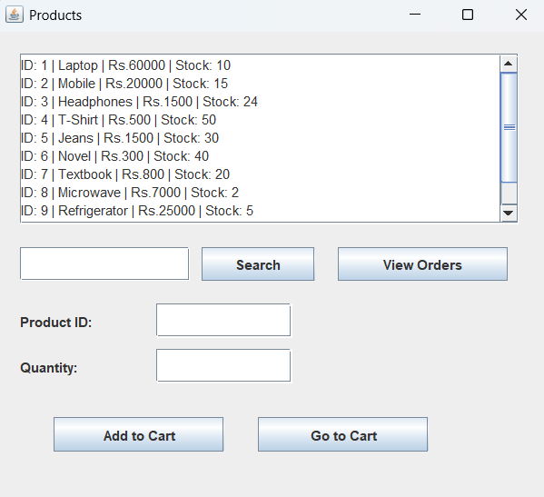 Figure 5.2

SEARCHING A PRODUCT:

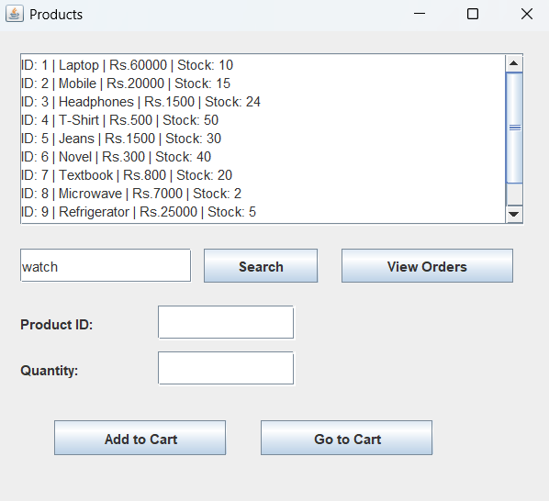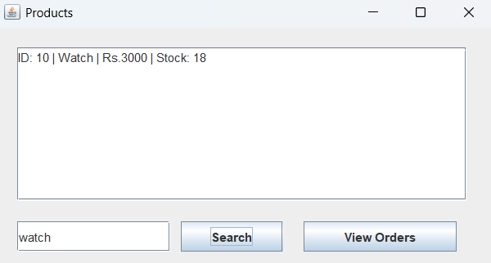
Figure 5.3

ADDING A PRODUCT INTO THE CART:

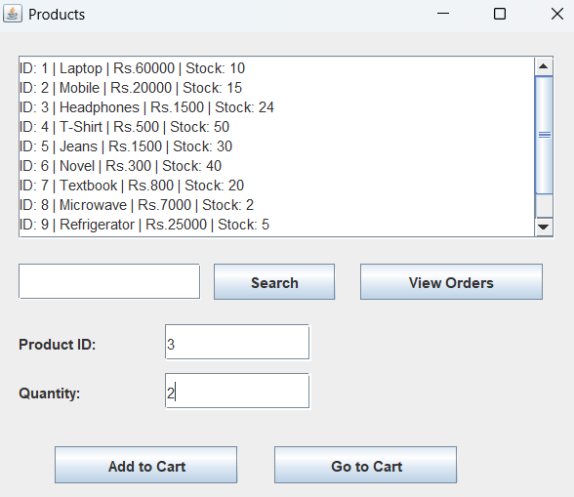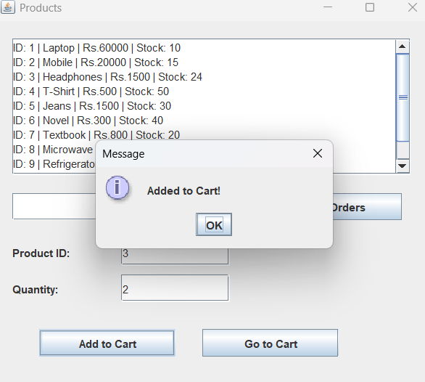
Figure 5.4

SHOPPING CART:

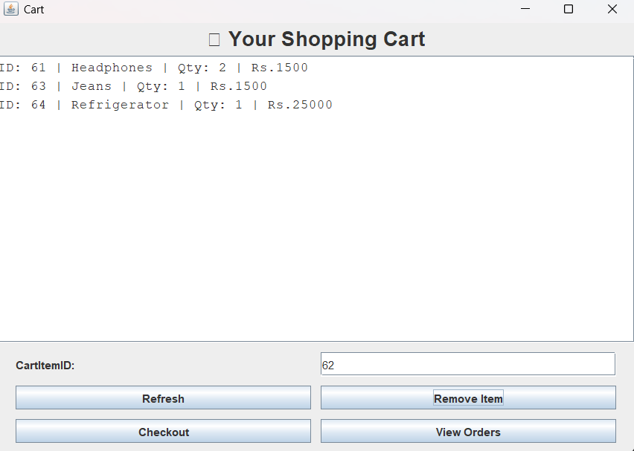
Figure 5.5

REMOVING AN ITEM:

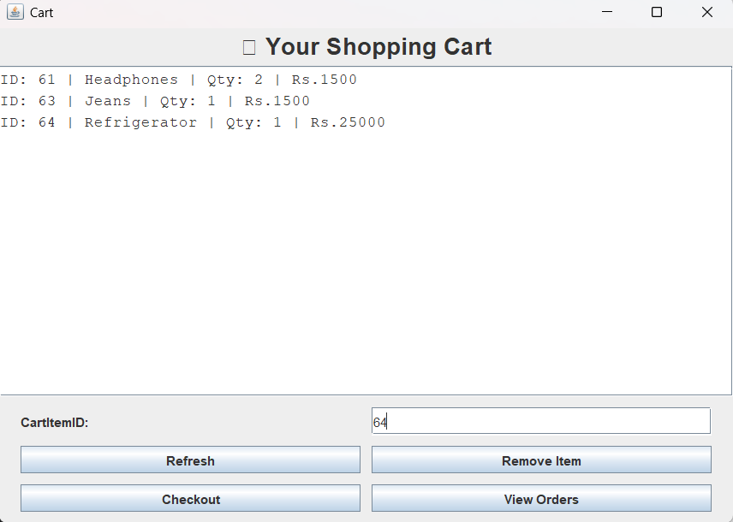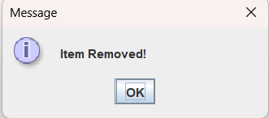
Figure 5.6

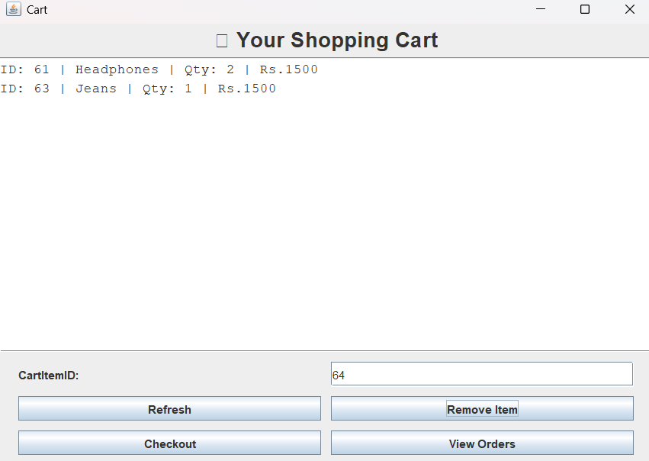
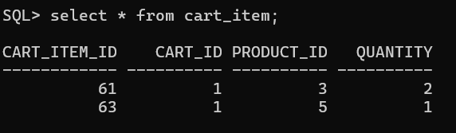

CHECKOUT PAGE:

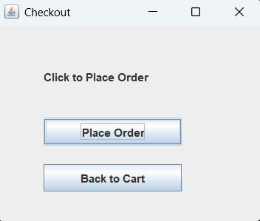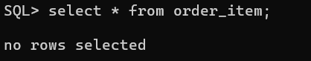
Figure 5.7

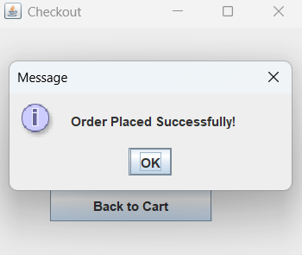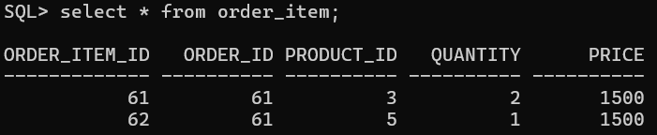

ORDER HISTORY PAGE:
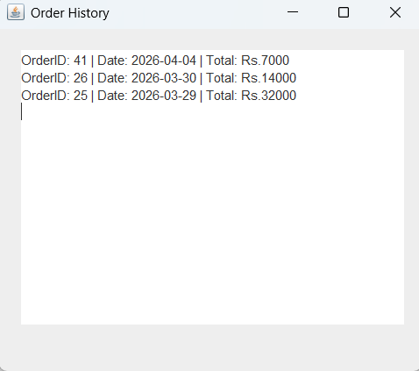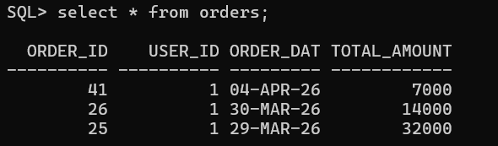
Figure 5.8

ADMIN PAGE:

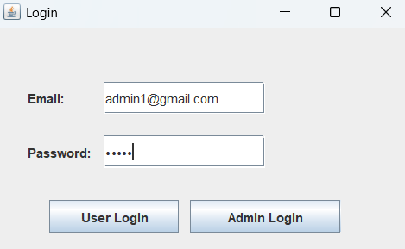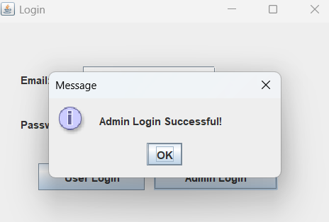

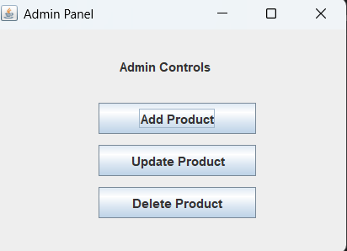 Figure 5.9

ADDING A PRODUCT:

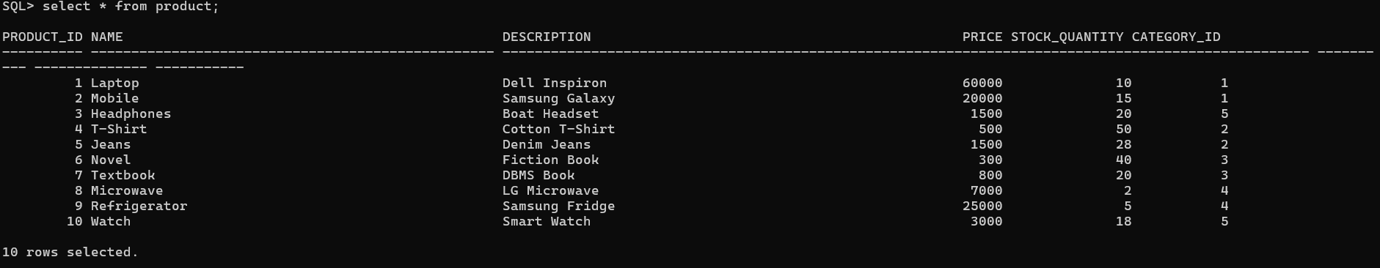

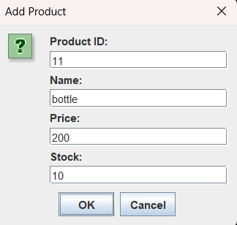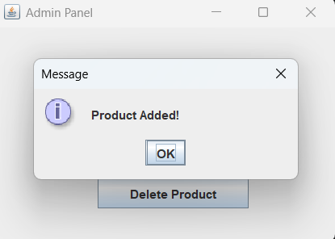
Figure 5.10

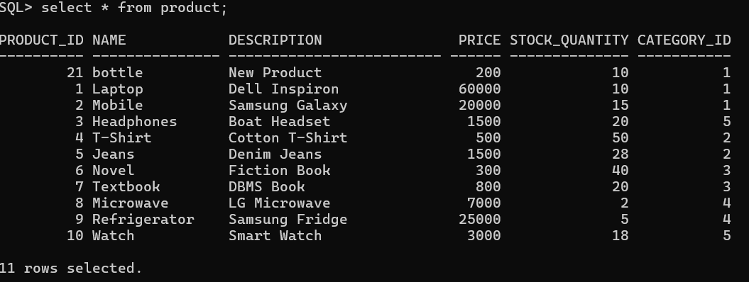

DELETING A PRODUCT:

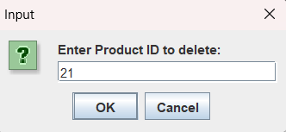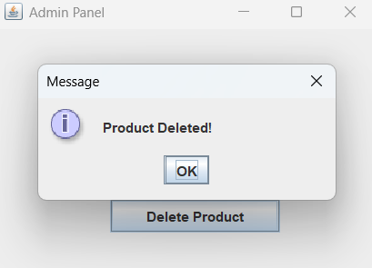
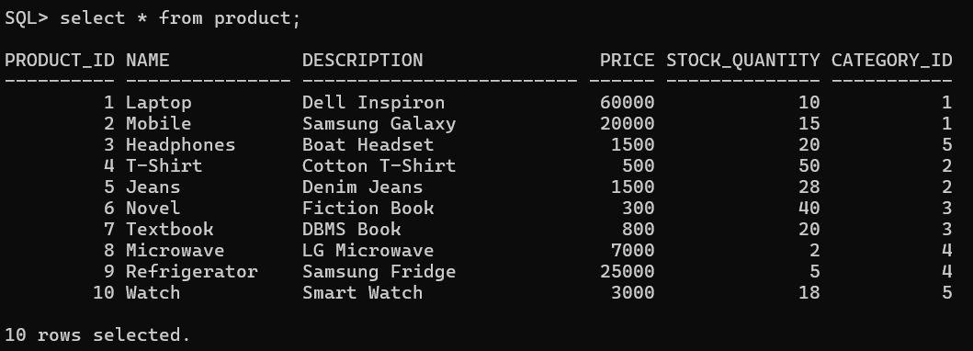

Figure 5.11

UPDATING A PRODUCT:

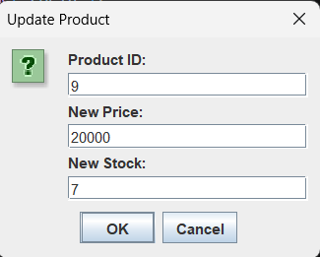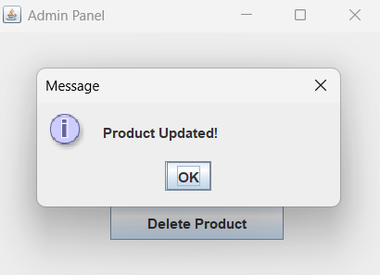

Figure 5.12

CHAPTER 6
CONCLUSION, LIMITATIONS & FUTURE WORK

  - Conclusion:

The Online Shopping Cart Management System shows how to design and build a database for managing online shopping activities. The system handles user information, product details, shopping cart tasks, and order processing in an organized way.
By using a relational database, the system keeps data consistent, cuts down on repetition, and makes data retrieval easy. Setting up relationships between entities like User, Product, Cart, and Order helps maintain transaction integrity.
The system also checks product availability before purchase and updates stock levels after an order is completed, which prevents invalid transactions. Overall, the project showcases how DBMS concepts can be applied in real life.

  - Limitations:

- There is no real-time-payment-gateway provision to process transactions.
- Encryption and authentication mechanisms are limited for security features.
- The user interface is rudimentary and lacks advanced user interaction.
- Lastly, it did not support real-time notifications and order tracking.
- The scalability is limited to handling many concurrent users.

  - Future Work:

- Integration of a secure online payment gateway for a full transaction process.
- Authentication and encryption techniques implementation to increase security.
- Development of a user-friendly graphical interface for enhanced usability.
- Inclusion of real-time features like order tracking and notifications.
- Refinement of the system for scalability for large-scale uses.
- Addition of sophisticated functionalities like product recommendations and user reviews.

CHAPTER 7
REFERENCES

[1] A. Silberschatz, H. F. Korth, and S. Sudarshan, Database System Concepts, 7th ed., McGraw-Hill, 2019.
[2] R. Elmasri and S. B. Navathe, Fundamentals of Database Systems, 7th ed., Pearson, 2016.
[3] Oracle Corporation, “Oracle Database SQL Language Reference,” [Online]. Available: https://docs.oracle.com
[4] “SQL Tutorial,” W3Schools, [Online]. Available: https://www.w3schools.com/sql/
[5] “Database Design Basics,” Microsoft Docs, [Online]. Available: https://learn.microsoft.com
[6] T. Connolly and C. Begg, Database Systems: A Practical Approach to Design, Implementation, and Management, 6th ed., Pearson, 2015.

